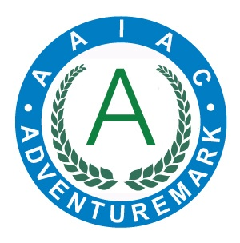
ADVENTUREMARK
www.adventuremark.co.uk
STUBBERS ADVENTURE CENTRE
Has met the necessary standards for the safe delivery of
adventure activities as defined by the
Adventure Activities Industry Advisory Committee.

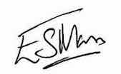
Elspeth Mason, Chair (AAIAC)

4x4 Driving | Kayaking
Abseiling | Leap of Faith
Archery | Mountain Boarding
Artificial Climbing Wall | Orienteering
Bell-boating | Rock Climbing
Bushcraft | Sailing
Canoeing | Sit on Top Kayaking
Caving – Artificial | Stand Up Paddle Boarding
Crate Stacking | Swimming – pool, sea, natural waters
High Ropes Courses
Jet Skis | Team Building

Date Issued : 10th November 2025 Expiry Date : 10th November 2027

Certificate No : AAA101099

